HR Analytics & Attrition Prediction Dashboard
1. Project Overview
The objective of this project was to design and deliver a data-driven HR Analytics solution that enables stakeholders to monitor workforce health, identify attrition patterns, and support proactive decision-making.
Using raw HR data from Excel, the project involved data extraction, transformation, modelling, KPI development, and advanced visualization in Power BI, resulting in a consolidated, interactive dashboard focused on employee attrition analysis and workforce insights.

2. Data Sources
- Primary Data Source: Excel (.xlsx) HR dataset
- Data Type: Structured HR master data
- Key Attributes:
  - Employee demographics (Age, Gender, Education)
  - Job details (Department, Role, Job Satisfaction)
  - Employment status (Active, Attrition)
The Excel file served as the single source of truth for all analytical outputs.
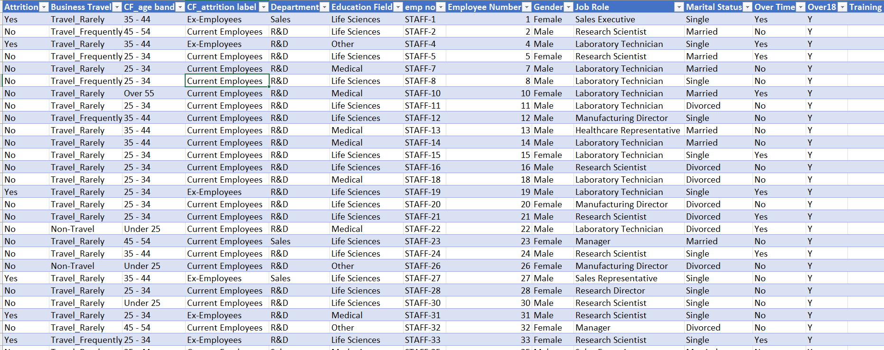

3. Power Query & ETL Process
Power Query was used extensively to implement a robust ETL (Extract, Transform, Load) pipeline, ensuring data accuracy, consistency, and analytical readiness.
3.1 Extract
- Imported raw Excel data directly into Power BI
- Verified schema alignment and column integrity
3.2 Transform
The following transformations were performed in Power Query Editor:
- Removed duplicates and null records
- Standardized column names for analytical clarity
- Converted data types (text, whole number, decimal)
- Created derived columns:
  - Age Group Buckets (Under 25, 25–34, 35–44, 45–54, Above 55)
  - Attrition Flag (Yes/No)
- Normalized categorical values (Department, Education Field, Job Role)

3.3 Load
- Loaded clean, transformed data into the Power BI data model
- Ensured optimized performance for slicers and visuals
This ETL layer ensures scalability, reusability, and governance readiness.

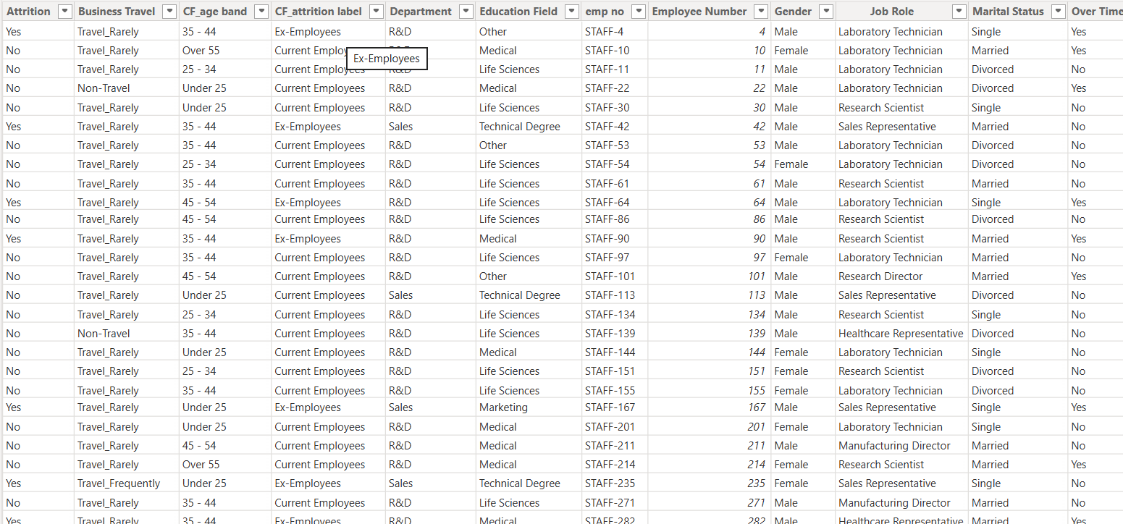

4. Data Modeling
- Implemented a flat star-like analytical structure optimized for reporting
- Established relationships between demographic, job, and attrition attributes
- Ensured filter propagation across visuals and KPIs
The model was intentionally kept lean and performant, aligning with best practices for HR analytics dashboards.

5. KPI Development (DAX Measures)
Custom DAX measures were created to translate raw data into actionable insights:
Core KPIs:
- Overall Employees
- Active Employees
- Total Attrition
- Attrition Rate (%)
- Average Employee Age
These KPIs act as executive-level indicators, dynamically responding to slicers and filters.

6. Dashboard Visualizations & Charts
A combination of descriptive, diagnostic, and comparative visuals were used:
6.1 Attrition Analysis
- Department-wise Attrition (Pie Chart)
Identifies attrition concentration across R&D, Sales, and HR.
- Education Field-wise Attrition (Bar Chart)
Highlights education backgrounds with higher attrition exposure.
6.2 Workforce Demographics
- Employee Count by Age Group & Gender (Stacked Column Chart)
Reveals workforce composition and gender distribution trends.
- Average Age KPI Card
Supports workforce maturity assessment.
6.3 Job Satisfaction Analysis
- Job Role vs Job Satisfaction Rating (Matrix/Table)
Enables granular evaluation of satisfaction across roles and rating levels.
6.4 Attrition by Age & Gender
- Donut Charts by Age Group
Visualizes attrition count and percentage split between male and female employees for each age band.
Each visualization was selected to answer a specific business question, not merely for aesthetics.
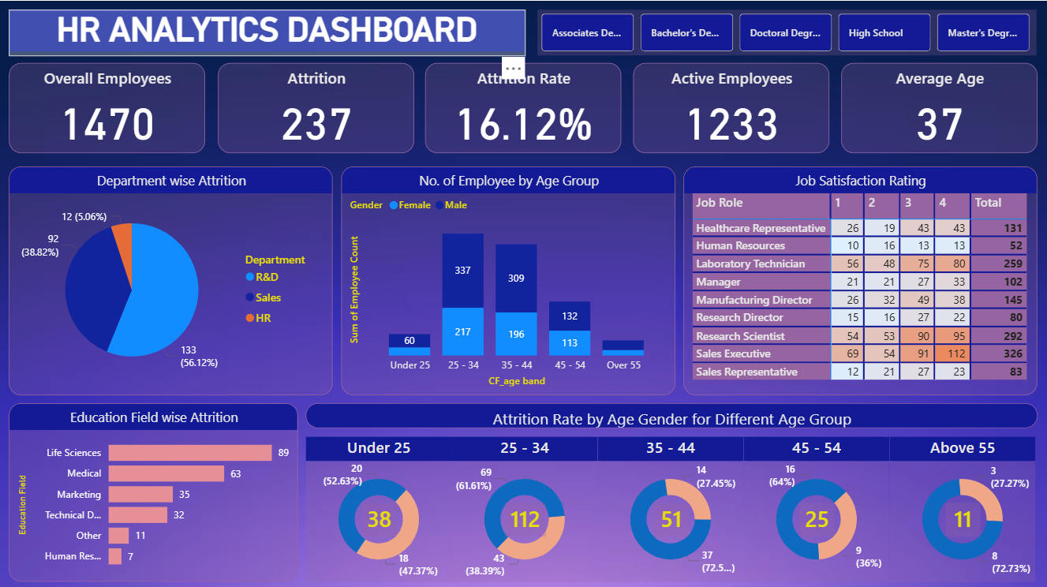

7. Conditional Formatting
- Applied conditional formatting in tables and matrices to:
  - Highlight high attrition-prone roles
  - Improve readability and decision focus
- Used color gradients aligned with dashboard theme for consistency
This enhanced visual cognition and executive consumption.

8. Slicers & Interactive Filtering
Interactive slicers were implemented for:
- Education Level
- Age Group
- Department
- Gender
Key Design Principle:
All slicers are fully synchronized with:
- KPI cards
- Charts
- Tables
This ensures cross-visual interaction, allowing stakeholders to drill down from KPIs into detailed insights seamlessly.

9. KPI–Visual Connectivity
- KPIs dynamically update based on slicer selections
- Visuals cross-filter each other to support exploratory analysis
- Enables top-down and bottom-up analytical navigation
This creates a true decision-support system, not just a static report.

10. Business Insights & Outcomes
- Identified attrition-heavy departments and roles
- Revealed age-group and gender-specific attrition patterns
- Highlighted education fields with higher employee churn
- Provided leadership with actionable intelligence for retention strategies
The dashboard empowers HR teams to move from reactive reporting to proactive workforce planning.

11. Tools & Technologies Used
- Microsoft Excel – Raw data source
- Power BI Desktop –
  - Power Query (ETL)
  - DAX (Measures & KPIs)
  - Data Modeling
  - Interactive Dashboard Design

